**Lab: For-Loop**

Problems for in-class and homework exercises for the course ["Programming Basics" @ SoftUni](https://softuni.org/).

Test your solutions in the **Judge** system: <https://judge.softuni.org/Contests/3493/For-Loop-Lab-PS>

## Numbers from 1 to 100

### Write a function that prints the numbers from 1 to 100, each on a new line.

### Sample Input and Output

|  |  |
| --- | --- |
| **Input** | **Output** |
| (no input) | 1  2  3  …  98  99  100 |

### Hints and Guidelines

1. Create a **new file named "numbers1To100".**
2. Go to the function body and write the solution to the problem. You can help yourself with the code from the image below:

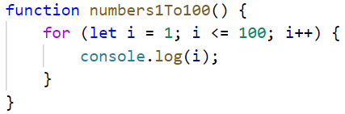

### Testing in the Judge System

Test the solution to this problem here: <https://judge.softuni.org/Contests/Compete/Index/3493#0>

## Numbers N...1

Write a function solve(num) that receives a positive number **n** entered by the user and prints **the numbers from n to 1 in reverse order**. The entered number **n** will always be greater than 1.

### Sample Input and Output

|  |  |  |  |  |  |  |  |
| --- | --- | --- | --- | --- | --- | --- | --- |
| **Input** | **Output** |  | **Input** | **Output** |  | **Input** | **Output** |
| solve(2) | 2  1 | solve(3) | 3  2  1 | solve(5) | 5  4  3  2  1 |

### Hints and Guidelines

1. Convert the given number from a string to a numeric type.
2. Make **a for-loop from n to 0**, but **instead of increasing the variable i** by 1, **decrease it by 1** at **each iteration of the loop:**

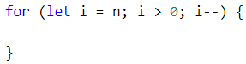

1. **In the loop body, print the variable i**:

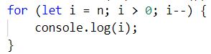

### Testing in the Judge System

Test the solution to this problem here: <https://judge.softuni.org/Contests/Compete/Index/3493#1>

## Numbers 1...N with Step 3

Write a function solve(num) that receives a number **n** and prints the **numbers from 1 to n with step 3**.

### Sample Input and Output

|  |  |  |  |  |  |  |  |
| --- | --- | --- | --- | --- | --- | --- | --- |
| **Input** | **Output** |  | **Input** | **Output** |  | **Input** | **Output** |
| solve(10) | 1  4  7  10 | solve(7) | 1  4  7 | solve(15) | 1  4  7  10  13 |

### Hints and Guidelines

1. Make a **for-loop from 1 to n** (**inclusive**) and set the **step to 3**. This means that at each iteration of the loop, the variable **i** **will increase its value by 3 instead of 1:**

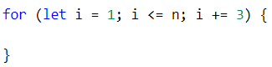

**In the loop body, print the variable i**:

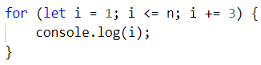

### Testing in the Judge System

Test the solution to this problem here: <https://judge.softuni.org/Contests/Compete/Index/3493#2>

## Even Powers of 2

Write a function solve(num) that receives a number **n** and **prints the even powers of** **2** **≤** **2n**: **20**, **22**, **24**, **26**, …, **2n**.

### Sample Input and Output

|  |  |  |  |  |  |  |  |  |  |  |  |  |  |
| --- | --- | --- | --- | --- | --- | --- | --- | --- | --- | --- | --- | --- | --- |
| **Input** | **Output** |  | **Input** | **Output** |  | **Input** | **Output** |  | **Input** | **Output** |  | **Input** | **Output** |
| solve(3) | 1  4 | solve(4) | 1  4  16 | solve(5) | 1  4  16 | solve(6) | 1  4  16  64 | solve(7) | 1  4  16  64 |

### Testing in the Judge System

Test the solution to this problem here: <https://judge.softuni.org/Contests/Compete/Index/3493#3>

## Character Sequence

Write a function solve(text) that receives **text** (string) and prints each **character** of the string on a separate line.

### Sample Input and Output

|  |  |  |  |
| --- | --- | --- | --- |
| **Input** | **Output** | **Input** | **Output** |
| solve("softuni") | s  o  f  t  u  n  i | solve("ice cream") | i  c  e  c  r  e  a  m |

### Hints and Guidelines

1. Make a for-loop with the initial value of the control variable from 0 to input.length (the length of the string). At each iteration, take the letter at the position in the input word equal to the value of the control variable i, by []

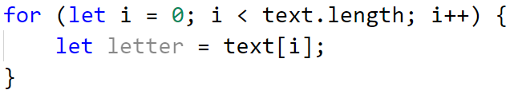

1. At each iteration, print the value of the variable **letter**:

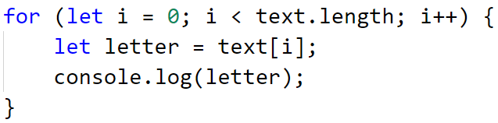

### Testing in the Judge System

Test the solution to this problem here: <https://judge.softuni.org/Contests/Compete/Index/3493#4>

## Vowels Sum

Write a function solve(text) that receives, calculates, and prints the sum of the vowel values according to the table below:

|  |  |  |  |  |  |
| --- | --- | --- | --- | --- | --- |
| Letter | a | e | i | o | u |
| Value | 1 | 2 | 3 | 4 | 5 |

### Sample Input and Output

|  |  |  |
| --- | --- | --- |
| **Input** | **Output** | **Comments** |
| solve("hello") | 6 | e + o = 2 + 4 = 6 |
| solve("hi") | 3 | i = 3 |
| solve("bamboo") | 9 | a + o + o = 1 + 4 + 4 = 9 |
| solve("beer") | 4 | e + e = 2 + 2 = 4 |

### Testing in the Judge System

Test the solution to this problem here: <https://judge.softuni.org/Contests/Compete/Index/3493#5>

## Sum of Numbers

Write a function solve(n) that receives an integer **n**, **sums** all its digits, and prints the **sum.**

### Input Data

The function receives a **number n**.

### Output Data

Print on the console on a single line:

"The sum of the digits is:{**sum**}" – where **sum** is the sum of the individual digits.

### Sample Input and Output

|  |  |  |  |  |
| --- | --- | --- | --- | --- |
| **Input** | **Output** |  | **Input** | **Output** |
| solve(1234) | The sum of the digits is:10 | solve(564891) | The sum of the digits is:33 |

### Testing in the Judge System

Test the solution to this problem here: <https://judge.softuni.org/Contests/Compete/Index/3493#6>

## Numbers, Divisible by 9

Write a function solve(num1, num2) that receives two numbers and prints to the console all the numbers in the range that are divisible by 9 without remainder, and their sum. On the first line, print the sum of the numbers, and on the following lines, print the numbers that meet the condition.

### Sample Input and Output

|  |  |
| --- | --- |
| **Input** | **Output** |
| solve(100,200) | The sum: 1683  108  117  126  135  144  153  162  171  180  189  198 |

### Testing in the Judge System

Test the solution to this problem here: <https://judge.softuni.org/Contests/Compete/Index/3493#7>